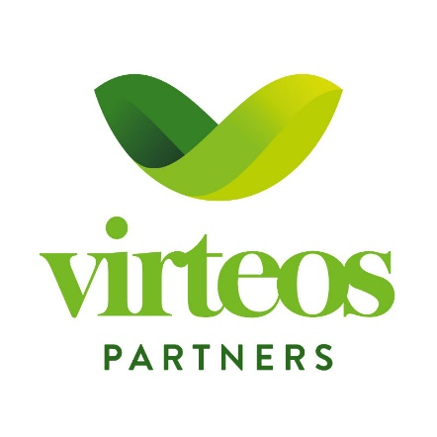

Industry: Cancer Treatment
Volume in EUR: 5 Mio.
Instrument: Convertible Bond / Loan or Equity
The target is raising funds for a cutting-edge medical process that utilizes proprietary and validated technology for the non-invasive treatment of cancer. With a functional prototype already developed, the company has achieved promising results in initial testing phases. The company’s imminent endeavors include conducting pivotal organoid tests and trials on living organisms, marking a significant stride towards medical advancement. The process is set to reach market readiness within the next 24 months.
Cancer Treatment – Project „AEGIS“
Inquiries: Dr. Herta Vanas | herta.vanas@virteos.at |+43 664 850 10 90

